GDD GAM200F12

2012 Fall
Team Luchadores
Game Name: N/A
Kristopher "Bear" Timchuck

Dillon Marsh (BFA)
Role: Animation Artist
Jobs: Storyboards, UI Art, Enemy Animations
Dayton Hoffart (BFA)
Role: Environmental Artist
Jobs: Environmental Art, Sound, Music
Chevy Vall (RTIS)
Role: Programmer
Jobs: Enemy AI, Sound, Music
Peter Nicholas Nodiff (BFA)
Role: Lead Artist/Animator
Jobs: Character Art, Enemy Art, Concept Design, Animations, Mask Art
Tyler Howard (RTIS)
Role: Programmer
Jobs: Animation Controller, Graphics, Collision
James Clark (RTIS)
Role: Technical Director
Jobs: Architecture, Factory
Kristopher "Bear" Timchuck (RTIS)
Role: Producer/Lead Designer
Jobs: Gameplay, Level Design, Enemy Design, Story, Dialogue

Contents
Table of Contents...............................................................................................1
Introduction.......................................................................................................2
Game Flow.........................................................................................................3
Game Mechanics................................................................................................4
Game Characters...........................................................................................5-10
Game Resources...............................................................................................11
Game Environment...........................................................................................12
Game Controls..................................................................................................13
Visual Design....................................................................................................14
Audio Design....................................................................................................15
Behavior Design................................................................................................16
Physics Design..................................................................................................17
Multiplayer Design...........................................................................................18
Appendix A: Story.............................................................................................19
Appendix B: Art List.....................................................................................20-26
Appendix C: Audio List.................................................................................27-30
Appendix D: Interface Flow..........................................................................31-35

INTRODUCTION
Our game is a 2D side-scrolling action platformer with an emphasis on combat and using the terrain to make attacks more accessible. Our game features The Protagonist, a world renown scientist who secretly wants to be a luchador. The game will feature our Protagonist as a luchador who is lost in a laboratory, he will use combat moves from Lucha Libre and collect masks that serve as equipment along the way. As long as The Protagonist has a mask equipped he will be able to use that mask's ability (ex. if he has the Bull Mask on he will be able to charge through certain obstacles). The environment in the game will offer the player a fair amount of freedom for exploration and unique play styles. The player can simply engage enemies head-on in combat or they can use the terrain to jump off of and change their plan of attack.(much like a real Lucha Libre fighter would use ropes or posts to attack). This journey will be able self-discovery for The Protagonist, along this journey he will learn what it truly means to be a Luchador.
GAME FLOW
What does the player do when gameplay starts?
When the game starts (after the main menu) the player will watch a cut scene made up of story boards. At the end of the cut scene a machine will blow up and The Protagonist will be knocked through a wall and into an unknown area of his laboratory; after he is knocked through the path back to his lab will be blocked and he must advance forward.
How will this immediately engage him in the game?
Since The Protagonist will be confused about how this unknown area of his laboratory exists he will be driven by curiosity to explore this area of the lab. When the player enters this new laboratory he will be taunted by the Scientist Boss. This should hook the player into advancing through the laboratory.
How will he progress?
The player will progress by constantly pushing forward. Since the game is a sidescroller with the player being unable to progress by moving left, the player will always be pushing forward to the right and by doing so advancing in the level.
Why will he want to progress?
For each section the motivation for the player and the protagonist to progress will be different. In the first section, the lab, they will both be driven by curiosity (curiosity about the lab and this other scientist).
What is the nature of the experience he should be having (action, thinking, etc.)?
Initially the player will be driven by intrigue, but as soon as gameplay picks up (a few minutes into the game), we want to the player to be driven by action. They will be in combat a majority of the game, but we will break up gameplay with action/reaction oriented puzzles and cut-scenes made up of storyboards.
What are the "verbs" of the game?
Free, Jumping, Fighting; The game is a platformer so naturally there will be jumping, but we want to also include fighting. On top of that we want the player to feel a certain amount of freedom in their style of gameplay. The player will be able to use whatever mask they feel most comfortable with, or be able to use all of them.
How long does a single session take?
Ideally the player will not want to put the game down, but just in case we are going to put in save points. Checkpoints will be roughly every 15-20mins. We are aiming to make a difficult, engaging, and addicting game.
GAME MECHANICS
How do things move?
Everything moves horizontally, with the exception of the player, which may also jump. Enemies will patrol back and forth using state machines and once the player gets close enough to them (and in line-of-sight) they will attack the player. The player uses jumping as his main mechanic to get around the map.
How is damage done?
The player will deal damage by striking the enemy with strikes; they will be able to head-butt, leg sweep, and drop kick.
The enemies will deal damage by various attacks. The normal robot and the crawling robot will both strike The Protagonist and the flying enemies will shoot lasers at The Protagonist.
How do you score points?
There is no scoring system.
How do you win?
The player wins by defeating enemies and advancing to the boss of each section of the game. Once the player defeats the final boss they will win the game.
How do you lose?
We have no system for tracking lives and we do not intend on having one. So technically they player cannot lose our game. They can repeatedly die over and over again and revert to the last checkpoint that they passed, but they will not be able to receive a "Game Over." There are two reasons for this, one of which is that we want our game to be challenging, but also we want the players to strive to beat our game. Winning through perseverance is our goal.
What statistics does the game use?
There are no statistics in our game.
How does line-of-sight work?
Our game has an aggro system. When the player is within a certain distance and is in line-of-sight of an enemy the enemy will attempt to engage into combat with the player.
How about noise detection?
None.
GAME CHARACTERS:
Protagonist:
Statistics: He will have less health than all of the bosses, but more health than all of the lesser enemies. As in most games, bosses should be a challenge for the player, but the lesser enemies should be less of a challenge. However, since we are making our game somewhat difficult the enemies will not simply be fodder to amuse the player between boss fights.
Abilities: The Protag's will have access to certain abilities 100% of the time. These consist of a high attack (drop kick ), a low attack (leg sweep), a head butt and an elbow drop. As the player progresses through the game they will find and equip new masks. Each mask will add a different ability to the Protag's arsenal and it will be up to the player to decide which ability is right for a given situation. (See Mask section below). These masks abilities will only be usable while that given mask is equipped.
Purpose: This is the main character, our story revolves around him. He is the medium for the player to experience the game.
Concept Art:
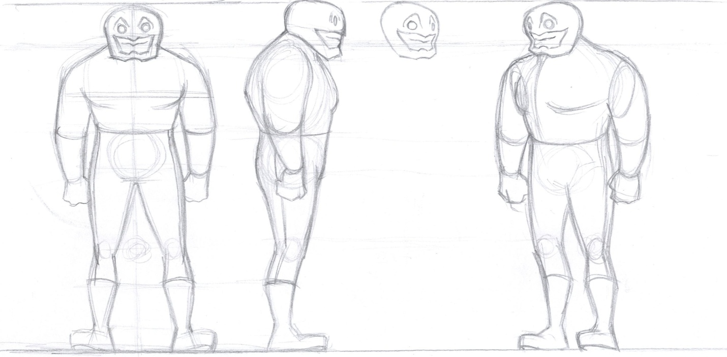

Back-story: The Protagonist is a world renowned scientist who secretly masks as a luchador wrestler. However he is too shy about his luchador life so he keeps it a secret. Throughout the course of the game the player as well as the protagonist will grow to accept their inner luchador.

Masks:
Bull: One of the earliest masks that the player will find is the Bull Mask. The Bull Mask will enable the player to perform a charge ability that both destroys certain terrain and damages enemies.
Eagle: Another mask that the player will find is the Eagle Mask. The Eagle Mask will enable the player to jump higher and glide when he is in the air. However, it will also reduce the maximum amount of damage the player can take in combat.
Gecko: This mask will allow the player to climb walls and scale ceilings.
Armadillo: This mask will increase the player's defensive capabilities. He will be able to dodge certain attacks, by rolling into a ball as well as explore new areas but rolling through otherwise impossible to reach places.

Minions of the science lab:
Normal:
The generic enemies of the science lab are robots. They are created by the boss of this portion of the game and their job as minions is to protect the laboratory.
Statistics: These enemies will be pretty generic all around. The will have no special abilities, moderate health and low damage.
Abilities: This enemy will patrol back and forth until it is aggroed by the player. When it has line-of-sight and the aggro is triggered they will engage in combat.
Purpose: The purpose of this enemy is to get the player comfortable will all the combat abilities before overwhelming the player with all of the different melee attacks. These enemies are here for the player to try and out any style of combat that they choose.
Concept Art:
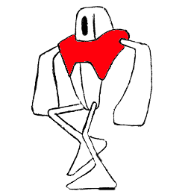

Back-story: This is one of the various robots created by the Scientist Boss.
Flyer:
Statistics: This enemy will be unable to be hit by the low attacks of player. It will deal moderate damage and have fairly low health.
Abilities: This enemy will fly around and shoot lasers at the player. Most likely these attacks will stun the player preventing them from taking actions for a certain amount of time.
Purpose: The purpose of this enemy is be a nuisance to the player and provide aid to the other enemies.
Back-story: This is another robot created by the Scientist Boss.

Low:
Statistics: This will be a low to the ground skittering robot. It will have low health, but will deal high damage.
Abilities: This enemy will attack the players legs with strikes or a saw attack.
Purpose: The purpose of this enemy is to provide an additional challenge to the player (the player must learn what enemies are vulnerable to certain attacks).
Back-story: This is another robot created by the Scientist Boss.

Mini-boss:
The mini-boss will be two very large luchadores. These luchadores will have a reoccurring presence throughout the game. Even though the player will defeat these enemies over and over again, they will continue to be punished into submission.
Statistics: These enemies will not be as strong as a full fledged boss, but there will be two of them so this will be the challenge for the player.
Abilities: When the player triggers the mini-boss fights they will be locked into a ring like arena and be forced to fight these two opponents.
Purpose: The purpose of the mini-bosses is to break up the lull of just fighting generic enemies; throughout the course of the game this will also show how the player has grown in strength.
Back-story: Essentially these are just giant luchador goons that work for the bosses.

Scientist Boss:
This is the first main boss that the player will encounter. The idea behind this boss is that the Scientist is a reflection of the Protagonist's brain. The boss will appear in a flying contraption of some kind.
Statistics: This boss will have a relatively low amount of health, but a high, spiky damage output.
Abilities: He will fly around and try his best to avoid the player since he is very fragile. He will attack with ranged attacks, such as bombs or chemicals and will also summon waves of enemies for the player to battle.
Purpose: The purpose of this enemy is to bring excitement to the game with a boss fight and for the player to overcome (and accept) the scientist aspect of his life.
Concept Art:
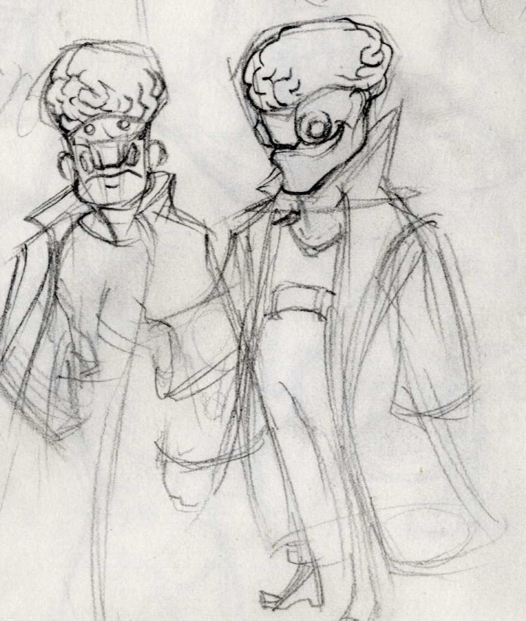
Back-story: This boss is another scientist that has taken up residence in the Protagonist's lab. Until the beginning of our journey the Protagonist did not even know about him, but the player will quickly find out about this sinister foe and his robot army. He is actually a personification of the player's mind.
Etc.: To defeat this boss it will be up to the player to scale the walls and knock the Scientist to the ground. When he is on the ground the player can deal damage easier than trying to combat him in the air.

Luchador Boss:
Statistics: This boss will be very reminiscent of the mini-boss luchadores. However he will have much more health and deal much more damage. He has high damage output and high health.
Abilities: We want this fight to pay homage to the sport of Lucha Libre. This boss will be able to grapple as well as have access to all of the base attacks that The Protagonist has.
Purpose: This is the real turning point for the player. Once he defeats this boss he will nearly be fulfilled as a luchador. This boss represents the luchador aspect of his life (his heart).
Back-story: This is subliminally the heart of the player. He must overcome this boss to realize how much being a luchador means to him.

Final Boss:
Statistics: This boss will be fought in stages. Each getting progressively more difficult and each stage will add to the drama of the fight. With this final battle we really want to capture the thematic feel of Lucha Libre.
Purpose: This is the climax of the game. This boss fight is the building point of the entire game.
Back-story: This is The Protagonist's soul. He must battle himself and overcome himself before he will be at peace.

Stage 1: Mind
Statistics: This stage of the boss fight will be very similar to the first boss fight of the game. The player will get the same feel of a fight as they did with the first boss fight (avoid the boss's attacks and take him down), but we will add new elements to keep this fight fresh.
Abilities: He will have similar attacks to the scientist but we will add new ones as well.
Stage 2: Heart
Statistics: This stage of the boss fight will be similar to the fight with the giant luchador. It will be a straight out brawl. This time around the boss will be much tougher and much more aggressive.
Abilities: The boss will have access to all of the abilities of the giant luchador boss. He will have much more health this time.
Stage 3: Soul aka "Nega Lucha"
The climax of this fight will be with The Protagonist's soul.
Statistics: This stage will be a culmination of the previous two fights as well The Protagonist himself.
Abilities: He will have access to all of the abilities of the previous bosses as well as all of the masks that the Luchador has. The player will truly have to overcome himself in order to defeat this foe.
GAME RESOURCES
Health: This is pretty basic. When the player gets hit (or an enemy) they lose health. Once all of their health is gone, they are destroyed.
Equipment/Abilities: Each mask is technically equipment that grants the player access to a certain ability while it is equipped.
Bull Mask:
When this mask is equipped the player will be able to charge. Charging can destroy certain objects, such as crates.
Concept Art:
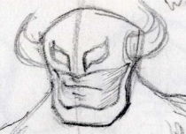

Eagle Mask:
When this mask is equipped the player will be able to glide. This helps the player get across gaps he normally would not be able to get across as well as traverse terrain that would otherwise be un-accessible.
Concept Art: None.
Gecko Mask:
When this mask is equipped the player will be able to climb walls. This is a tool that will allow a level of vertical exploration. There will be certain walls that the gecko mask will not work on.
Concept Art: None.
Armadillo Mask:
When this mask is equipped the player will gain the ability to roll into a ball. This is important because it offers the player a variety of defensive options. They can use the ball to roll over spike traps as well as dodge enemy attacks. If the player hits an enemy with enough force with the ball that enemy will be knocked back.
Concept Art: None.

GAME ENVIRONMENT
Describe the environments in which the game takes place, and any related game mechanics.
As of right now we are planning on the entirety of the game taking place in the Laboratory. Inside the Lab there will be various hazards such as spike pits and electric traps. The player must advance through the laboratory fighting various enemies and avoiding many hazards.

How do characters interact with terrain?
For a majority of the game the player will simply be walking across platforms (because it is a platformer) but we are also adding a lot of cool features to make this different from generic platformers. One key interaction with the environment is that the player can grab walls and perform different attacks off of them; this is to replicate real luchadores jumping off ropes and posts in the ring. Another cool thing that we are going to add is the Gecko mask, the Gecko mask will allow players to climb walls vertically as well as across ceilings.

How does the environment affect movement?
Platforms will block horizontal progression and it will be up to the player to jump and wall grab to advance past these. In cases where that is even impossible the player will have to use the Eagle mask or the Gecko mask to find an alternative route.

How does the environment do damage?
There will be various hazards such as spike traps and electric wires. If the player collides with these they will be instantly killed (unless they are in the armadillo roll).

GAME CONTROLS
The player will use an XBOX 360 controller or a keyboard to play our game.
XBOX 360 Controls:
Left Joystick: This will be used to move the player around.
A Button: This will allow the player to jump.
X Button: This will allow the player to use light attacks.
Y Button: This will allow the player to use heavy attacks.
B Button: This will allow the player to grab a wall.
Right Trigger: This will allow the player to use the activated ability of the current mask they have equipped.
Left Bumper and Right Bumper: These will allow the player to cycle through the masks they currently own.

Keyboard Controls:
Arrow Keys: These will allow the player to move around.
Space: This will allow the player to jump.
Q Button: This will allow the player to use light attacks.
W Button: This will allow the player to use heavy attacks.
E Button: This will allow the player to grab a wall.
R: This will allow the player to use the activated ability of the current mask they have equipped.
Number Keys: These will allow the player to cycle through the masks they currently own.

VISUAL DESIGN
The game is a 2D sidescroller. The camera will follow the player (so the player will always be at the center of the screen. Our game will use hand drawn (and then touched up in Photoshop) sprites as well as a custom background. We will have dynamic Z-order draw as well as parallaxing that will allow certain objects to appear in front of the player. We are going for a cartoony platformer (it is reminiscent of a platformer on the SNES). There will be no specialized lighting needed, it is mostly just a cartoony pseudo-realistic looking platformer.
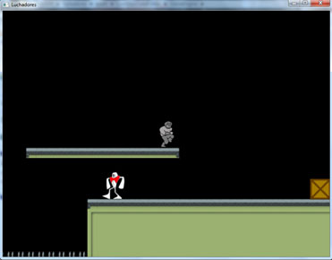

AUDIO DESIGN
We will have a custom soundtrack in our game. The overall feel will be an 8-bit soundtrack that corresponds to the intensity in the game (as far as story and setting are concerned).The music will change based on level progression; the music will build up as the player advances through the level and the music will come to a climax when the player is fighting a boss. We will have around 11 tracks, 2 for each section of the game, 1 for each boss fight, 1 for the pause menu, and 1 for the main menu.
As far as sound effects go, we will have numerous sound effects. Basically one for every action in the game. For these we will create homemade sounds and/or use the free stuff in the sound library. We want them be realistic what they are supposed to represent. The player attacks will sound like strikes, the enemy attacks (such as the laser) will sound like a laser. We want them to be in the came to immerse the player into the experience (i.e. the sounds should feel like they belong) and not rip them out of the experience.
We have not decided on whether or not we are going to have recorded voice in the game. We did voiceovers for our last two games so we are very familiar with the process. We want to develop the game more before we decide if voiceovers will be detrimental or beneficial to the game.

BEHAVIOR DESIGN
The computer-controlled characters will patrol back and forth in a given zone. When the player comes into their aggro-zone and is in their line-of-sight they will engage in combat with the player. In combat they will use their specific attack against the player. When multiple enemy types are engaged with the player their attacks can be used in conjunction to make the game more difficult for the player (i.e. the flying enemy may stun the player while the normal robot strikes him with a melee attack). So to a certain extent they will coordinate, but this will be more apparent on boss fights. Their AI is pretty simplistic; they will just go from a state of patrolling to a state of attacking the player. They simply switch from state to state based on certain criteria. If the player is not in range, patrol back and forth; if the player is near me, destroy him.

PHYSICS DESIGN
Our physics is pretty simple, we have collision and response (for things such as combat and spike hazards), rotating objects (for flying enemies and the armadillo roll), and gravity. We are not focusing too heavily on physics so our gameplay will be pretty simplistic in regards to physics.

MULTIPLAYER DESIGN
Our game will only be single player; there will be no multiplayer.

APPENDIX A: STORY
Our game focuses around a world renown scientist with a secret passion for lucha libre; for now he is simply known as The Protagonist. The game will open with a storyboard/cut-scene highlighting both his world renown fame and ingenuity as well as his burning passion for lucha libre to be a bigger part of his life. The story will then transition into The Protagonist working on an experiment in his laboratory; something will then go wrong and the experiment will blow up and knock The Protagonist through a wall. To his surprise he will be in an unfamiliar part of his laboratory; his intrigue will drive him to explore this uncharted section of his laboratory. While going through this area he will run into various enemies and eventually bosses. He will first run into the Scientist Boss; this is the man that has built these additions onto The Protagonist's laboratory. Upon defeating this Scientist the player will be immediately attacked by a very strong, very big Luchador. However, the player will easily defeat him. After his defeat this new enemy will turn tail and run like a coward; to stop the luchador from chasing him, dozens of his henchmen (also luchadores) will dog pile onto The Protagonist. The Protagonist will easily dispatch these enemies, but it will be too late to catch the giant Luchador. The Protagonist will now be motivated to pursue this new foe, because he will be upset at these cheap tactics. The Protagonist will pursue this new foe, defeating the giant Luchador's minions along the way. When The Protagonist finally reaches the giant Luchador another battle will ensue. After the big Luchador is defeated The Protagonist will continue his journey. He will eventually come into conflict with a mysterious man. After a short storyboard/cut-scene The Protagonist and this mysterious man will fight. (This is the climax of the game, he is the final boss and The Protagonist will have to defeat him in stages) When the Protagonist first engages with this foe the enemy will resemble and behave like the first boss, after The Protagonist defeats this enemy there will be a short transition and after the transition The Protagonist will engage in another fight with this same foe, but this time he resembles the Giant Luchador boss. The player will defeat him and yet again another cut scene will follow. During this part The Protagonist and the mysterious man will bet masks before they fight. By this time the Protagonist will be abundant in his pride for Lucha Libre and it will show in this confrontation. When the player finally defeats this foe The Protagonist will unmask this foe; to The Protagonist's shock this mysterious man will be The Protagonist. It will then be revealed that The Protagonist has been fighting with himself this whole time, The Scientist (his mind), The Giant Luchador (his heart), and The Mysterious Man (his soul). After finally defeating all of these foes and ending this long journey The Protagonist will have come to accept his life as a Luchador. There will then be an epilogue of some kind. Probably similar to the opening storyboard.

APPENDIX B: ART LIST

Protagonist Sprites:
Description: These are the sprites required for the default player costume.
File Format: .png
Exact Size: 64 x 64 pixels
Number of frames of Animation:
16 -Walking (includes the 2 for jumping)
4 - Idle
16 - Attacks
2 - Wall Grab

Protagonist in Bull Suit Sprites:
Description: These are the sprites required for the Bull costume.
File Format: .png
Exact Size: 64 x 64 pixels
Number of frames of Animation:
16 -Walking (includes the 2 for jumping)
4 - Idle
16 - Attacks
2 - Wall Grab
2- Bull Charge

Protagonist in Eagle Mask Sprites:
Description: These are the sprites required for the Eagle costume.
File Format: .png
Exact Size: 64 x 64 pixels
Number of frames of Animation:
16 -Walking (includes the 2 for jumping)
4 - Idle
16 - Attacks
2 - Wall Grab
3 - Gliding

Protagonist in Gecko Mask Sprites:
Description: These are the sprites required for the Gecko costume.
File Format: .png
Exact Size: 64 x 64 pixels
Number of frames of Animation:
16 -Walking (includes the 2 for jumping)
4 - Idle
16 - Attacks
2 - Wall Grab
4 - Wall Climbing

Protagonist in Armadillo Mask Sprites:
Description: These are the sprites required for the Armadillo costume.
File Format: .png
Exact Size: 64 x 64 pixels
Number of frames of Animation:
16 -Walking (includes the 2 for jumping)
4 - Idle
16 - Attacks
2 - Wall Grab
1- Armadillo Ball
3- Animations into Armadillo Ball

Normal Robot Sprites:
Description: These are the sprites required for Normal Robot.
File Format: .png
Color Depth:
Alpha Channels:
Exact Size: 64 x 64 pixels
Number of frames of Animation:
4 -Walking
4 - Attacks

Flying Robot Sprites:
Description: These are the sprites required for Flying Robot.
File Format: .png
Exact Size: 64 x 64 pixels
Number of frames of Animation:
1 -Flying
4 - Attacks

Low Robot Sprites:
Description: These are the sprites required for Low Robot.
File Format: .png
Exact Size: 64 x 64 pixels
Number of frames of Animation:
4 -Walking
4 - Attacks

Mini-Boss A Sprites:
Description: These are the sprites required for Mini-Boss A.
File Format: .png
Exact Size: 64 x 64 pixels
Number of frames of Animation:
16 -Walking (includes the 2 for jumping)
16 - Attacks
2 - Grab

Mini-Boss B Sprites:
Description: These are the sprites required for Mini-Boss B.
File Format: .png
Exact Size: 64 x 64 pixels
Number of frames of Animation:
16 -Walking (includes the 2 for jumping)
16 - Attacks
2 - Grab
These are just a re-coloring of all of the sprites for Mini-Boss A.

Scientist Boss Sprites:
Description: These are the sprites required for the scientist boss.
File Format: .png
Exact Size: 64 x 64 pixels
Number of frames of Animation:
16 -Moving
16 - Attacks

Luchador Boss:
Description: These are the sprites required for the Luchador Boss.
File Format: .png
Exact Size: 64 x 64 pixels
Number of frames of Animation:
16 -Walking (includes the 2 for jumping)
24 - Attacks
Final Boss Sprites:
Description: These are the sprites required for the Final Boss.
File Format: .png
Exact Size: 64 x 64 pixels
Number of frames of Animation:
Stage 1:
All of the frames of animations for Scientist Boss, just re-colored.
Stage 2:
All of the frames of animations for the Luchador Boss, just re-colored.
Stage 3:
All of the frames of animations for the Protagonist, just re-colored.

Misc Sprites:
Description: Various sprites for pick-ups in the game.
File Format: .png
Exact Size: 25 x 25 pixels
Number of frames of Animation:
1 - Bull Mask
1 - Eagle Mask
1 - Gecko Mask
1 - Armadillo Mask
1 - Health

Main Menu Sprites:
Description: These are the sprites required for Mini-Boss A.
File Format: .png
Exact Size: unknown
Number of frames of Animation:
1 - Button
1 - Background
1 - Title

Tile Sprites:
Description: These are the sprites required for creating the terrain.
File Format: .png
Exact Size: 25 x 25 pixels
Number of frames of Animation:
16 -One for each different tile

Source:
These will be created by our art team.

APPENDIX C: AUDIO LIST
Music: List every piece of music your game will need. Include details such as file name, music description, file format, sampling frequency, stereo or mono, looping or not, bit rate, compression, etc. You are allowed to have a directory where your game will play any music placed in that directory - but your final submission cannot include any music you did not create.
Source: Describe the source of sources of all the audio in your game.
Sounds:
Jump Sound
Description: This sound will play when the player jumps, it will be a faint jumping noise.
File Format: .ogg
Stereo
Laser Sound
Description: This sound will play when the flying enemy shoots. It will sound like a laser.
File Format: .ogg
Stereo
Charge Sound
Description: This sound will play when the player charges in the bull mask.
File Format: .ogg
Stereo
Death Sound
Description: This sound will play when the player dies.
File Format: .ogg
Stereo
Hit Enemy Sound
Description: This sound will play when the player strikes the enemy.
File Format: .ogg
Stereo
Pick-up Sound
Description: This sound will play when the player picks up an item.
File Format: .ogg
Stereo
Menu Click Sound
Description: This sound will play when the player clicks on a button in the menu.
File Format: .ogg
Stereo
Get Hit Sound
Description: This sound will play when the player gets hit by an enemy attack.
File Format: .ogg
Stereo

Music
Section 1a Song
Description: This sound with be somewhat whimsical and electronic. It will ease the player into gameplay.
File Format: .mp3
Stereo
Section 1b Song
Description: This will be a slight modification on the previous song, but it will increase the song's tempo and intensity.
File Format: .mp3
Stereo

Scientist Boss Fight Song
Description: This song will be an intense science-esq electric song. It will add to the climax of the battle.
File Format: .mp3
Stereo
Section 2a Song
Description: This will be a new song, it will be more action oriented.
File Format: .mp3
Stereo
Section 2b Song
Description: This is a modification on the previous song, it will add intensity and speed to the song.
File Format: .mp3
Stereo
Giant Luchador Boss Fight Song
Description: This song will be reminiscent of a fighting game, but will draw queues from Lucha Libre culture. This is an intense fight between two luchadores and the song should reflect that.
File Format: .mp3
Stereo
Section 3a Song
Description: This song is very resounding and absolute. The player will know that the game is building to a climax.
File Format: .mp3
Stereo
Section 3b Song
Description: This song is a modification of the previous song. It will have a lot of build up, because it is leading to the final boss.
File Format: .mp3
Stereo
Final Boss Fight Song
Description: This song will be very intense. It will add to the climax of the game.
File Format: .mp3
Stereo
Source: All of this music and sound effects will be either made by the game team or taken from the sound libraries.

APPENDIX D: INTERFACE FLOW
Credits
Load Saved Game
Start
Main Menu Screen
Game Intro Screen
Team Splash Screen
DigiPen Splash Screen
Cutscene

Game

Pause Menu Screen

Exit Pause
Respawn at Last Checkpoint
Save Game

Gameplay

After Final Boss

Cutscene

Victory Screen

Mockups:
DigiPen Splash Screen
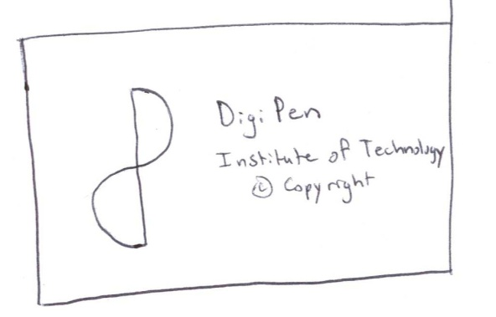
Team Splash Screen
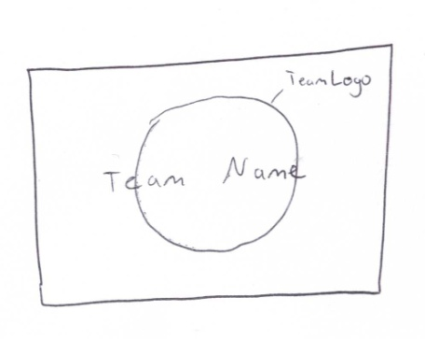
Game Intro Screen
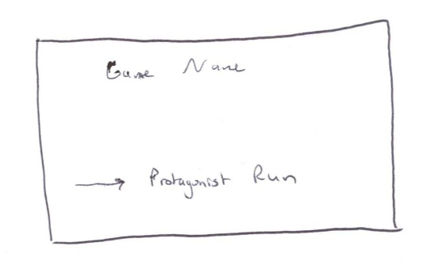
Main Menu Screen
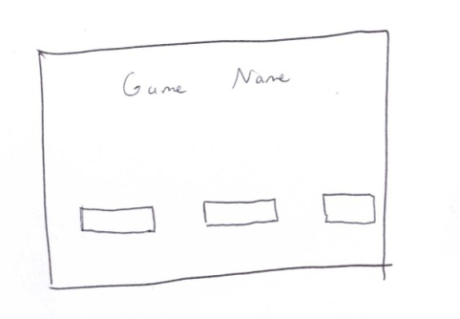

Gameplay
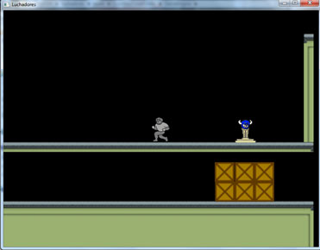
Victory Screen
